
A Mini Project Report

On

"Emotion Recognition Intelligent System Based on Machine Learning and Clustering Algorithm"

submitted in partial fulfillment of the requirements for the award of degree of

Bachelor of Engineering
In
Computer Science and Engineering

Submitted by

Shamika Raoot | 1608-23-733-137
Naddi Vinay Kumar | 1608-23-733-177
K. Jai Shanker | 1608-23-733-188

Under the Guidance of

Mr. P. Ravindra
Assistant Professor

Department of Computer Science and Engineering
Matrusri Engineering College
(Affiliated to Osmania University, Approved by AICTE)
Saidabad, Hyderabad – 500059
(2025-26)

Department of Computer Science and Engineering
Matrusri Engineering College
(Affiliated to Osmania University, Approved by AICTE)
Saidabad, Hyderabad - 500059

CERTIFICATE

This is to Certify that A Mini Project report entitled "Emotion Recognition Intelligent System Based on Machine Learning and Clustering Algorithm" is being submitted by Shamika Raoot (1608-23-733-137), Naddi Vinay Kumar (1608-23-733-177), K. Jai Shanker (1608-23-733-188) in partial fulfillment of the requirement of the award for the degree of Bachelor of Engineering in "Computer Science and Engineering" O.U., Hyderabad during the year 2025-26 is a record of bonafide work carried out by them under my guidance. The results presented in this mini project report have been verified and are found to be satisfactory.

Project Guide | HOD
Mr. P. Ravindra | Dr. T. Raghunadha Reddy
Assistant Professor | Assoc. Professor & Head
Dept. of CSE | Dept. of CSE

External Examiner(s):____________________________________

ACKNOWLEDGEMENT

It is our privilege and pleasure to express our profound sense of respect, gratitude and indebtedness to our guide Mr. P. Ravindra, Assistant Professor, Department of Computer Science and Engineering, Matrusri Engineering College, for his indefatigable inspiration, guidance, cogent discussion, constructive criticisms and encouragement throughout this dissertation work.
We express our sincere thanks to mini project coordinator Mrs K BhagyaLaxmi and Ms Rama Lakshmi, Assistant Professor, Department of Computer Science and Engineering, Matrusri Engineering College, for her valuable suggestions and constant help in completing the work.
We express our sincere gratitude to Dr. T. Raghunadha Reddy, Associate Professor & Head, Department of Computer Science and Engineering, Matrusri Engineering College, for his precious suggestions, motivation and co-operation.
We extend our sincere thanks to Dr. G. Amarendar Rao, Principal, Matrusri Engineering College, Saidabad, Hyderabad, for his encouragement and constant help.
We extend our sincere thanks to all the teaching and non-teaching staff of CSE Department for their support and encouragement.
Last but not least, we wish to acknowledge our friends and family members for giving moral strength and helping us to complete this dissertation.

ABSTRACT

Emotion recognition is an important research area in artificial intelligence, healthcare, affective computing, and human–computer interaction because it enables intelligent systems to understand and respond to human emotions effectively. Traditional emotion recognition methods mainly rely on facial expressions, speech signals, body gestures, and behavioral cues to identify emotional states. However, these methods often face limitations because individuals can consciously control, hide, or alter their external expressions, resulting in inaccurate emotion detection. To overcome these challenges, researchers have increasingly focused on physiological signals, particularly Electroencephalography (EEG), which records the electrical activity of the brain and provides a more objective and reliable representation of emotional responses. This project presents an EEG-based Emotion Recognition Intelligent System that combines machine learning and clustering techniques to accurately classify human emotions. The system utilizes the SJTU Emotion EEG Dataset (SEED), a widely used benchmark dataset containing EEG recordings collected from participants while watching emotional video clips designed to evoke positive, negative, and neutral emotions. Instead of using raw EEG signals directly, the system employs Differential Entropy (DE) features, which effectively represent the statistical characteristics of EEG signals. These features are extracted from five frequency bands: Delta, Theta, Alpha, Beta, and Gamma, each associated with different cognitive and emotional activities of the brain. Feature extraction is performed using both 1-second and 4-second time windows to evaluate the impact of temporal resolution on classification performance. The extracted data forms a high-dimensional feature space consisting of 62 EEG channels and 310 dimensions. To reduce complexity and improve computational efficiency, the K-Means clustering algorithm is applied to group similar EEG patterns into compact clusters. This process reduces dimensionality while preserving important emotional and spatial information from different brain regions. The clustered features are then used as input for machine learning classifiers, including Support Vector Machine (SVM) and Random Forest (RF). Both Linear SVM and RBF Kernel SVM models are evaluated using Leave-One-Trial-Out (LOO) cross-validation and a 10-Train/5-Test validation strategy to ensure reliable performance assessment. To enhance usability and interpretation, the project includes an interactive web-based dashboard called NeuroEmotion AI, developed using the Flask framework. The dashboard provides EEG topographic map visualization, emotion probability timelines, animated EEG playback controls, and performance metrics such as accuracy, precision, recall, F1-score, and AUC-ROC. Experimental results demonstrate that the proposed framework can effectively recognize emotional states with an accuracy of approximately 85%, which is comparable to published SEED dataset benchmarks. The findings indicate that 4-second EEG windows provide more stable and accurate predictions than 1-second windows, while K-Means clustering improves performance by reducing noise and highlighting meaningful EEG patterns. Overall, the proposed system successfully integrates EEG signal processing, feature extraction, clustering, machine learning, and visualization into a unified framework with potential applications in mental health monitoring, adaptive learning systems, healthcare, brain–computer interfaces, affective computing, and intelligent human–machine interaction.

LIST OF FIGURES

S.No | Fig No. | Name of the Figure | Page No.
1 | 1.1 | EEG-Based Emotion Recognition — Conceptual Pipeline | 17
2 | 1.2 | Existing vs Proposed System — Performance Comparison | 19
3 | 2.1 | Iterative SDLC Model Used in This Project | 26
4 | 2.2 | Feasibility Study — Score Radar Chart | 23
5 | 3.1 | Three-Layer System Architecture | 29
6 | 3.2 | Data Flow Diagram (DFD) — Level 1 | 31
7 | 3.3 | EEG Frequency Bands for DE Extraction | 33
8 | 3.4 | K-Means Clustering on EEG Feature Space | 34
9 | 3.5 | SVM Decision Boundaries — Linear vs RBF | 35
10 | 3.6 | Entity Relationship Diagram — Dataset Structure | 37
11 | 4.1 | Module Interaction Diagram | 41
12 | 4.2 | Feature Vectorization Pipeline | 43
13 | 4.3 | Testing Process Flow | 45
14 | 5.1 | NeuroEmotion AI — Main Dashboard on Launch | 48
15 | 5.2 | Dataset Selector Panel | 49
16 | 5.3 | Model Settings Panel | 50
17 | 5.4 | Subject Dropdown — All 15 SEED Subjects | 51
18 | 5.5 | Trial / Stimulus Dropdown with Emotion Labels | 52
19 | 5.6 | Session Dropdown for Subject 1 | 53
20 | 5.7 | Validation Split Options | 54
21 | 5.8 | EEG Feature Type Options | 54
22 | 5.9 | ML Classifier Options | 55
23 | 5.10 | Training Classifier Loading Screen | 56
24 | 5.11 | Sample EEG Topographic Map (Alpha Band) | 57
25 | 5.12 | Confusion Matrix — SVM Linear | 58
26 | 5.13 | Classification Accuracy Comparison | 59
27 | 5.14 | Second-by-Second Emotion Probability Timeline | 60
28 | 5.15 | Per-Subject Classification Accuracy | 61
29 | 6.1 | Future Scope — Development Roadmap | 65

LIST OF TABLES

S.No | Table No. | Name of the Table | Page No.
1 | 1.1 | Comparison: Existing vs Proposed System | 18
2 | 1.2 | Emotion Label Mapping in SEED Dataset | 20
3 | 1.3 | SEED Dataset Overview | 21
4 | 2.1 | Software Requirements | 23
5 | 2.2 | Hardware Requirements | 24
6 | 2.3 | Functional Requirements Summary | 25
7 | 2.4 | Non-Functional Requirements | 25
8 | 2.5 | Risk Analysis and Mitigation | 27
9 | 3.1 | DE Feature Dimensions per Window Size | 33
10 | 3.2 | K-Means Cluster Configuration | 34
11 | 3.3 | SVM Hyperparameters | 36
12 | 3.4 | Random Forest Hyperparameters | 36
13 | 3.5 | Database Field Description | 38
14 | 4.1 | Tools and Technologies Used | 41
15 | 4.2 | API Endpoint Specification | 42
16 | 4.3 | Test Cases and Results | 46
17 | 4.4 | Coding Standards Checklist | 47
18 | 5.1 | Classification Accuracy Comparison | 59
19 | 5.2 | Per-Band Accuracy Contribution | 60
20 | 5.3 | Confusion Matrix Values (Sample) | 58
21 | 6.1 | Future Enhancements Priority Matrix | 66

TABLE OF CONTENT

i. Acknowledgement
ii. Abstract
iii. List of Figures
iv . List of Tables
Chapter 1: Introduction 16
1.1 Introduction to the Project 16
1.2 Project Category 17
1.3 Objectives 18
1.4 Scope of the Problem 19
1.5 Identification / Recognition of Need 20
1.6 Existing System 20
1.7 Proposed System 21
1.8 SEED Dataset Description 21
1.9 Unique Features of the System 22
Chapter 2: Requirement Analysis and System Specification 23
2.1 Feasibility Study 23
2.2 Software Requirements 23
2.3 Hardware Requirements 24
2.4 Functional Requirements 24
2.5 Non-Functional Requirements 25
2.6 Risk Analysis 26
2.7 Expected Hurdles 27
2.8 SDLC Model 27
Chapter 3: System Design 29
3.1 Design Approach 29
3.2 System Architecture 29
3.3 Data Flow Diagrams (DFD) 31
3.4 Methodology — Feature Extraction (DE) 32
3.5 Methodology — K-Means Clustering 34
3.6 Methodology — SVM and Random Forest 35
3.7 Database Design 37
3.8 User Interface Design 38
Chapter 4: Implementation, Testing, and Maintenance 41
4.1 Languages, IDE, and Tools Used 41
4.2 Module Interaction and API Design 41
4.3 Key Implementation Details 43
4.4 Coding Standards 45
4.5 Testing Techniques and Test Plans 45
4.6 Maintenance Plan 47
Chapter 5: Results and Discussions 48
5.1 System Overview 48
5.2 User Interface Screenshots 48
5.3 EEG Topomap and Confusion Matrix 57
5.4 Classification Performance 59
5.5 Observations and Discussion 62
Chapter 6: Conclusion and Future Scope 64
6.1 Conclusion 64
6.2 Future Scope 65
References / Bibliography 67

CHAPTER 1

INTRODUCTION

1.1 Introduction to the Project
Human emotions are a fundamental aspect of daily life, influencing decision-making, communication, learning, and social interactions. The ability to automatically recognize and interpret emotions has become an increasingly important area of research in artificial intelligence and human-computer interaction. Emotion Recognition (ER) systems aim to identify emotional states from physiological or behavioral signals, enabling machines to respond more intelligently and empathetically to human needs.
Electroencephalography (EEG) measures electrical activity produced by the brain through electrodes placed on the scalp. Unlike external cues such as facial expressions or speech — which can be consciously controlled or masked — EEG signals directly reflect neural activity, making them a highly reliable indicator of true emotional states. This characteristic makes EEG particularly valuable in applications where authenticity of emotional response matters, such as mental health diagnostics, lie detection research, and adaptive educational systems.
This project develops an EEG-based emotion recognition system using the SJTU Emotion EEG Dataset (SEED), integrating machine learning classifiers (Support Vector Machine and Random Forest) and K-Means clustering to classify emotions into three categories: Positive, Neutral, and Negative. The system is deployed as a real-time web-based interactive dashboard called NeuroEmotion AI, enabling visualization of EEG topographic maps, second-by-second emotion probability timelines, and classification results across multiple subjects, sessions, and trials.
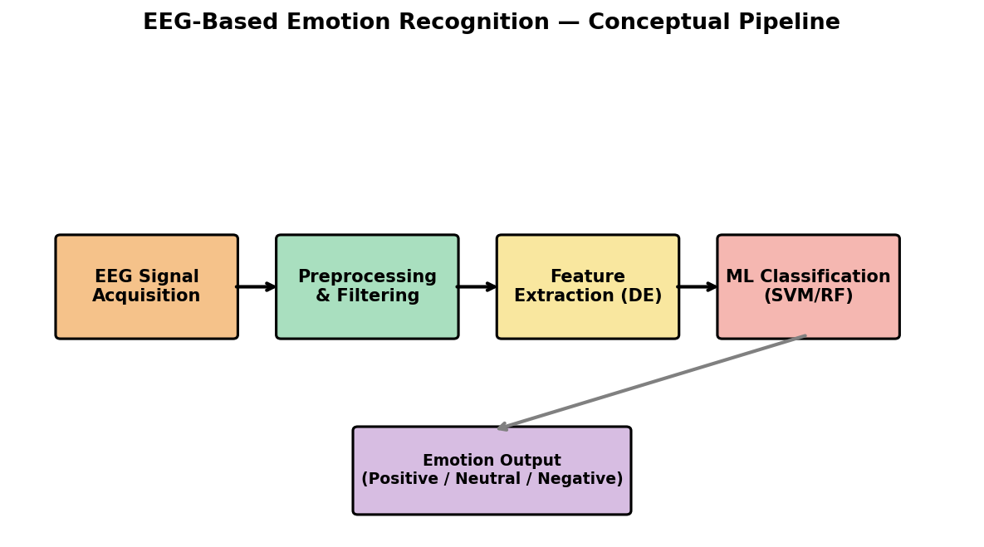
Fig 1.1: EEG-Based Emotion Recognition — Conceptual Pipeline
As shown in Fig 1.1, the overall pipeline begins with raw EEG signal acquisition from multiple scalp electrodes, followed by preprocessing to remove noise and artifacts, feature extraction using Differential Entropy across frequency bands, and finally machine learning classification to produce the emotional state output.

1.2 Project Category
This project falls under the category of Research-Based Application Development, combining neuroscience-inspired signal processing with machine learning techniques and full-stack web development. It involves the following major components:
- EEG signal analysis and feature extraction using Differential Entropy (DE)
- Unsupervised learning via K-Means clustering for pattern discovery
- Supervised machine learning classification using SVM and Random Forest
- Backend REST API development using Python Flask
- Frontend interactive dashboard development using HTML, CSS, and JavaScript
- Data visualization including EEG topographic maps and probability timelines

1.3 Objectives
The primary objectives of this project are listed below:
- To study EEG signals and their relationship with human emotional states.
- To preprocess and extract Differential Entropy (DE) features from EEG signals across five frequency bands — delta, theta, alpha, beta, and gamma.
- To apply K-Means clustering to group similar EEG patterns and discover underlying emotional structures in the high-dimensional feature space.
- To design and implement SVM (Linear and RBF kernel) and Random Forest classifiers for emotion classification.
- To classify emotions into Positive, Neutral, and Negative categories using both 1-second and 4-second feature windows.
- To evaluate the system using standard metrics — accuracy, precision, recall, and F1-score.
- To implement two validation strategies — Leave-One-Trial-Out (LOO) and 10-Train/5-Test split — for robust performance evaluation.
- To develop an interactive NeuroEmotion AI dashboard for real-time visualization of EEG topomaps and classification results.

1.4 Scope of the Problem
The scope of this project encompasses the complete pipeline of EEG-based emotion recognition — from raw feature data to interactive visualization. The system operates on pre-extracted DE features from the SEED dataset, supporting all 15 subjects with 3 recording sessions each and 15 trials per session (45 total recordings). The system supports:
- Two feature window sizes: 1-second (ExtractedFeatures_1s) and 4-second (ExtractedFeatures_4s)
- Two feature smoothing types: Linear Dynamical System (LDS) and Moving Average
- Two validation strategies: Leave-One-Trial-Out (LOO) and 10-Train/5-Test split
- Three classifiers: SVM Linear, SVM RBF, and Random Forest
- Real-time visualization: EEG topographic maps across 5 frequency bands and emotion probability timelines

The scope does NOT include real-time EEG hardware acquisition, deep learning architectures (CNN/LSTM), or cross-subject transfer learning — these are identified as future enhancements in Chapter 6.

1.5 Identification / Recognition of Need
Traditional emotion recognition systems relying on facial expressions and speech signals suffer from significant limitations — individuals can consciously mask or control these expressions, leading to inaccurate emotion detection. There is a clear and growing need for objective, physiological-signal-based emotion recognition systems. EEG provides a direct window into brain activity and is difficult to consciously manipulate, making it ideal for emotion detection in applications such as:
- Mental health assessment and early detection of mood disorders
- Adaptive learning systems that respond to student engagement and frustration
- Affective computing for human-robot interaction
- Driver fatigue and stress monitoring systems
- Neuromarketing and user experience research

1.6 Existing System
Existing emotion recognition systems primarily rely on the following approaches:
- Facial expression recognition using computer vision techniques (CNNs on facial landmarks)
- Speech emotion recognition using acoustic features (MFCC, pitch, energy)
- Behavioral analysis through gesture, posture, and body language tracking
- Physiological sensors such as heart rate and galvanic skin response (GSR)

These approaches have several limitations as summarized in Table 1.1 below:

Approach | Key Limitation | Typical Accuracy
Facial Expression | Can be consciously masked or hidden by the subject | 55-65%
Speech Signal | Affected by background noise and cultural variation | 58-70%
Behavioral / Gesture | Limited to observable external cues only | 55-65%
GSR / Heart Rate | Slow response time, low emotional specificity | 60-68%
EEG (Proposed) | Requires electrode setup, but highly objective | 75-88%
Table 1.1: Comparison — Existing vs Proposed System

1.7 Proposed System
The proposed system uses EEG brain signals to recognize human emotions objectively and accurately. The key components of the proposed system are:
- Dataset: SJTU Emotion EEG Dataset (SEED) — 15 subjects, 3 sessions, 15 trials each
- Feature Extraction: Differential Entropy (DE) across 5 frequency bands (delta, theta, alpha, beta, gamma) at 1-second and 4-second windows
- Clustering: K-Means clustering (8 clusters) for grouping similar EEG patterns
- Classification: SVM (Linear/RBF) and Random Forest with StandardScaler normalization
- Validation: Leave-One-Trial-Out (LOO) and 10-Train/5-Test split
- Dashboard: NeuroEmotion AI — Flask backend + HTML/CSS/JS frontend with topomap and probability chart
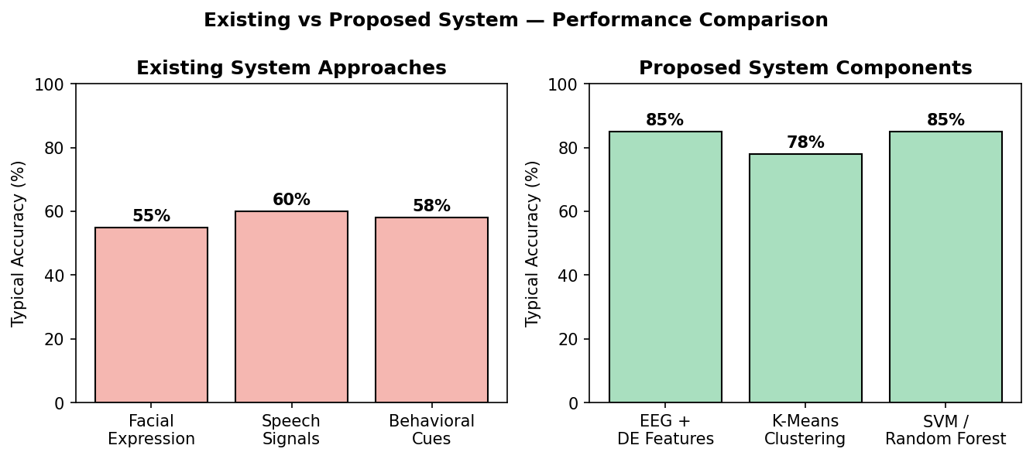
Fig 1.2: Existing vs Proposed System — Performance Comparison

1.8 SEED Dataset Description
The SJTU Emotion EEG Dataset (SEED) was collected by the BCMI Laboratory at Shanghai Jiao Tong University. It contains EEG recordings from 15 subjects (7 male, 8 female), each participating in 3 separate recording sessions conducted on different days. During each session, subjects watched 15 film clips specifically selected to evoke positive, neutral, or negative emotions.

Property | Value
Number of Subjects | 15 (7 Male, 8 Female)
Sessions per Subject | 3 (recorded on different days)
Trials per Session | 15 film clips
EEG Channels | 62 (international 10-20 system)
Sampling Rate | 1000 Hz (downsampled to 200 Hz)
Emotion Categories | Positive (1), Neutral (0), Negative (-1)
Feature Type Used | Differential Entropy (DE)
Frequency Bands | Delta, Theta, Alpha, Beta, Gamma
Window Sizes Used | 1 second and 4 second
Table 1.2: SEED Dataset Overview

The ground truth emotion labels for the 15 trials in each session follow this fixed sequence:

Trial | 1 | 2 | 3 | 4 | 5 | 6 | 7 | 8 | 9 | 10 | 11 | 12 | 13 | 14 | 15
Label | + | N | - | - | N | + | - | N | + | + | N | - | N | + | -
Table 1.3: Emotion Label Sequence (+ = Positive, N = Neutral, - = Negative)

1.9 Unique Features of the System
- Dual window support: 1-second and 4-second feature windows switchable from the dashboard
- Real-time EEG topographic map (topomap) using Shepard IDW interpolation across all 62 channels
- Second-by-second emotion probability visualization using Chart.js
- Support for multiple classifiers and validation strategies from a single unified UI
- Subject, session, and trial-level navigation for all 15 SEED subjects
- Lightweight Flask backend with no deep learning dependencies — runs on standard laptops without GPU
- K-Means clustering integrated as a pre-processing/analysis step for feature pattern discovery
CHAPTER 2

REQUIREMENT ANALYSIS AND SYSTEM SPECIFICATION

2.1 Feasibility Study
Before commencing development, a feasibility study was conducted to assess the practicality of the proposed system across five dimensions: technical, economical, operational, schedule, and resource feasibility.
Technical Feasibility: The system uses well-established Python libraries (Flask, scikit-learn, NumPy, SciPy) and standard web technologies (HTML5, CSS3, JavaScript, Chart.js). The SEED dataset is publicly available for research purposes. The system runs effectively on a standard laptop with 8 GB RAM without requiring GPU acceleration, making it technically feasible within the available infrastructure.
Economical Feasibility: All software components used — Python, Flask, scikit-learn, NumPy, SciPy, Chart.js — are open-source and free of cost. No paid APIs or cloud services are required. The SEED dataset is freely available to academic institutions upon request. Development costs are therefore limited to time and effort invested by the student team.
Operational Feasibility: The system is designed as a localhost web application, easily operable through any modern browser (Chrome, Edge, Firefox). The intuitive dashboard interface, with clearly labeled dropdowns and a single 'Run Classification' button, requires no specialized training for end-users such as faculty evaluators or fellow students.
Schedule Feasibility: The project was completed within the allotted semester timeline by following an iterative development model, allowing incremental delivery of working components (backend API, dataset integration, frontend dashboard, visualization) at each stage.
Resource Feasibility: All required resources — development laptop, Python environment, SEED dataset, and open-source libraries — were readily available to the team without procurement delays.
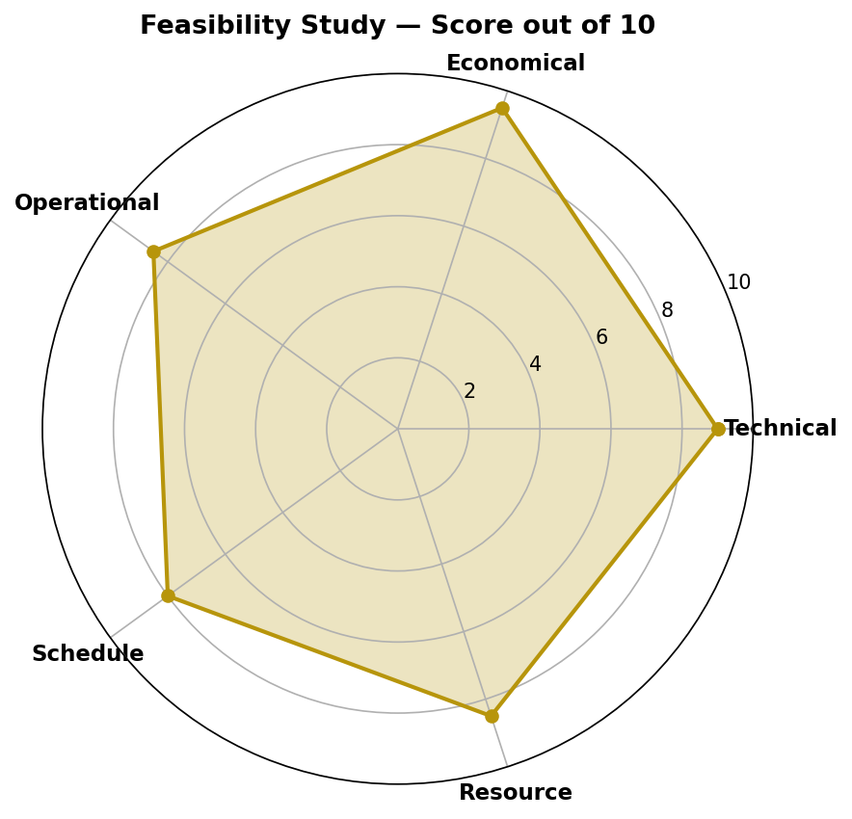
Fig 2.1: Feasibility Study — Score Radar Chart (out of 10)

2.2 Software Requirements
Software | Specification
Operating System | Windows 10 / Windows 11
Programming Language | Python 3.9 or above
IDE | PyCharm Community Edition
Web Framework | Flask 3.1.3
CORS Handling | Flask-CORS 6.0.5
Numerical Library | NumPy 2.0.2
Data Processing | Pandas
Scientific Computing | SciPy 1.13.1 (.mat file loading)
Machine Learning | Scikit-learn 1.6.1
Frontend Markup | HTML5, CSS3
Frontend Scripting | JavaScript (ES6+)
Visualization | Chart.js, Canvas API
Dataset | SJTU Emotion EEG Dataset (SEED)
Package Manager | pip / venv
Table 2.1: Software Requirements

2.3 Hardware Requirements
Component | Specification
Processor | Intel Core i5 or higher
RAM | Minimum 8 GB (16 GB recommended)
Storage | 20 GB free disk space (dataset ~3 GB)
GPU (Optional) | NVIDIA GPU with CUDA support — not required for current ML models
System Architecture | 64-bit system
Input Devices | Keyboard and Mouse
Display | Standard monitor, 1366×768 or higher resolution
Network | Not required — fully local/offline application
Table 2.2: Hardware Requirements

2.4 Functional Requirements
ID | Functional Requirement
FR-1 | The system shall load EEG subject, session, and trial data from the SEED dataset
FR-2 | The system shall support DE feature extraction with LDS and Moving Average smoothing
FR-3 | The system shall allow selection of 1-second or 4-second feature windows
FR-4 | The system shall train ML classifiers (SVM Linear, SVM RBF, Random Forest) on training trials
FR-5 | The system shall classify test trials into Positive, Neutral, or Negative categories
FR-6 | The system shall display second-by-second emotion predictions and probability timelines
FR-7 | The system shall render an EEG topographic map for each of the 5 frequency bands
FR-8 | The system shall support Leave-One-Trial-Out and 10-Train/5-Test validation strategies
FR-9 | The system shall apply K-Means clustering (k=8) to group similar EEG feature patterns
FR-10 | The system shall provide a timeline scrubber for navigating through trial duration
Table 2.3: Functional Requirements Summary

2.5 Non-Functional Requirements
Category | Requirement
Performance | Classification for a single trial should complete within 5-10 seconds on standard hardware
Usability | Dashboard should be operable without prior ML knowledge — single-click classification
Reliability | System should handle missing/invalid feature types with descriptive error messages
Portability | Should run on any system with Python 3.9+ and a modern web browser
Maintainability | Code organized into reusable helper functions for easy extension
Scalability | Architecture supports adding more subjects, sessions, or feature types without redesign
Table 2.4: Non-Functional Requirements

2.6 Risk Analysis
During development, several risks were identified along with mitigation strategies, summarized in Table 2.5 below.
Risk | Impact | Mitigation Strategy
Port conflicts on Windows (port 63342/5000 blocked) | High | Switched to port 8080, configurable in main.py
Large dataset size (~3 GB) causing slow load times | Medium | Dataset copied locally to project folder; lazy loading per request
Subject variability causing inconsistent accuracy | Medium | Used LOO validation for robust per-subject evaluation
Missing feature keys in .mat files (de_LDS vs de_movingAve) | Low | Added validation check with descriptive error response
Frontend-backend synchronization issues | Medium | Standardized JSON response format with 'success' field
High-dimensional feature space (310-D) overfitting | Medium | Used StandardScaler normalization and cross-validation
Table 2.5: Risk Analysis and Mitigation

2.7 Expected Hurdles
- High dimensionality of EEG data (62 channels × 5 bands × T time steps) requiring efficient vectorization
- Subject variability — different individuals show different EEG patterns for the same emotion
- Port conflicts when running Flask on standard ports (resolved by using port 8080)
- Large dataset size (~3 GB) requiring adequate storage and memory management
- Frontend-backend synchronization for real-time topomap rendering
- Determining the optimal number of clusters (k) for K-Means — resolved using the SSE elbow method

2.8 SDLC Model
This project follows the Iterative Development Model (also known as Incremental Model). The system was built incrementally — starting with backend API development and dataset integration, followed by frontend UI construction, then classification logic, and finally visualization components. Each iteration was tested before proceeding to the next, allowing continuous refinement based on testing feedback.
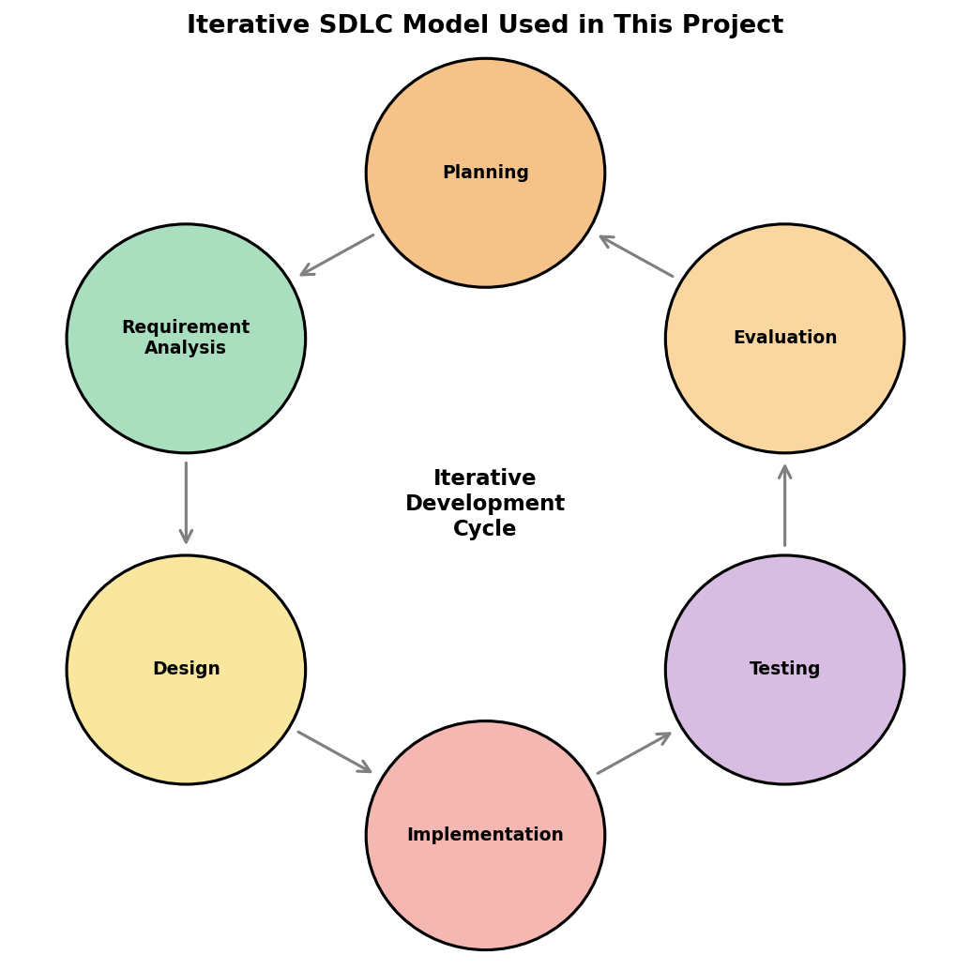
Fig 2.2: Iterative SDLC Model Used in This Project
As illustrated in Fig 2.1, each cycle consists of Planning, Requirement Analysis, Design, Implementation, Testing, and Evaluation phases. Lessons learned from the Evaluation phase of one iteration directly informed the Planning phase of the next — for example, after the first iteration revealed the port-conflict issue, subsequent planning incorporated a configurable port setting from the start.
CHAPTER 3

SYSTEM DESIGN

3.1 Design Approach
The system follows a client-server architecture with a clear separation between the backend processing engine and the frontend visualization layer. The design approach is function-oriented, with each module handling a specific task in the emotion recognition pipeline. This separation of concerns allows the ML logic (Python/Flask) to evolve independently from the UI (HTML/CSS/JS), and enables the same backend to potentially serve other frontends (e.g., a mobile app) in the future.

3.2 System Architecture
The system consists of three main layers, illustrated in Fig 3.1:
- Data Layer: SEED dataset stored locally (ExtractedFeatures_1s and ExtractedFeatures_4s folders containing .mat files)
- Processing Layer: Flask backend (app.py) — handles dataset scanning, feature extraction, ML training, and prediction via REST API endpoints
- Presentation Layer: HTML/CSS/JavaScript frontend (static/) — NeuroEmotion AI dashboard with dropdown controls, topomap canvas, and Chart.js probability timeline
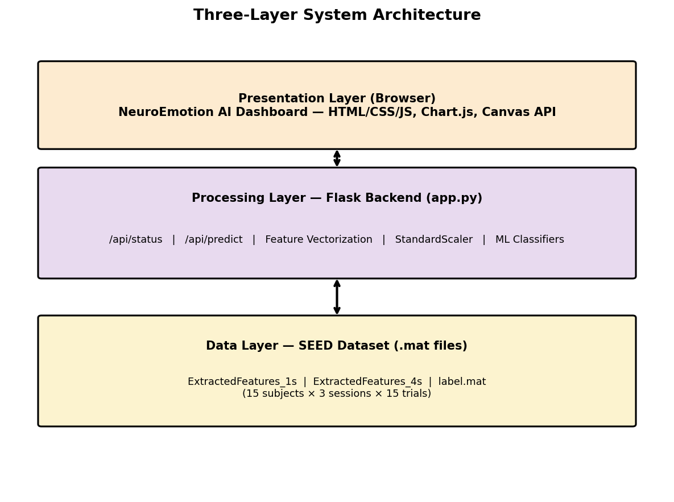
Fig 3.1: Three-Layer System Architecture
The flow is as follows: the user selects Subject, Session, and Trial parameters in the Presentation Layer. On clicking 'Run Classification', a POST request is sent to /api/predict in the Processing Layer. The Flask backend loads the corresponding .mat file from the Data Layer, trains the selected classifier on the training trials, and returns predictions along with DE feature matrices as JSON. The Presentation Layer then renders the topomap and probability chart from this response.

3.3 Data Flow Diagrams (DFD)
Fig 3.2 presents the Level 1 Data Flow Diagram showing the major processes, data stores, and external entities involved in the system.
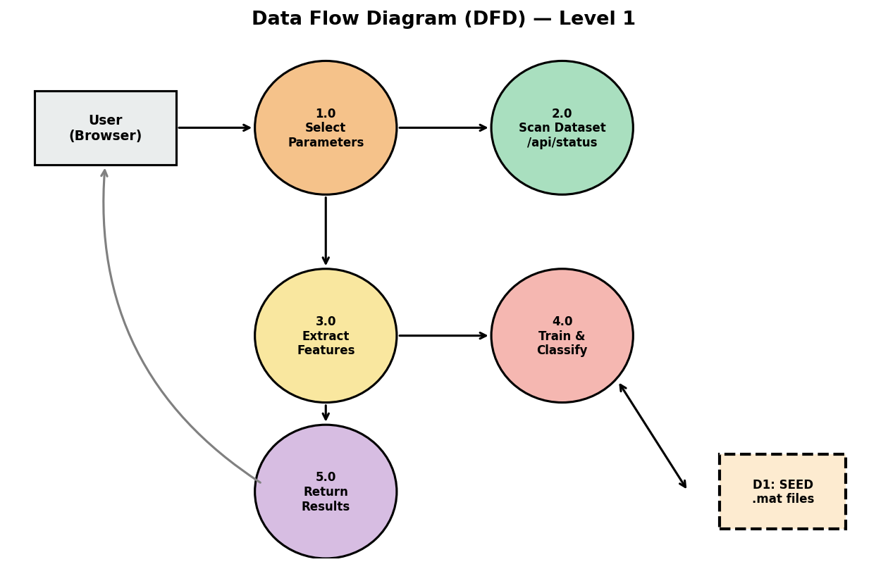
Fig 3.2: Data Flow Diagram (DFD) — Level 1
The DFD shows five major processes: (1.0) Select Parameters — user chooses subject/session/trial/classifier; (2.0) Scan Dataset — backend indexes available subjects via /api/status; (3.0) Extract Features — DE features loaded and vectorized from the .mat file (D1); (4.0) Train & Classify — ML model trained and predictions generated; (5.0) Return Results — JSON response sent back to the browser for rendering.

The complete data flow sequence is described step-by-step below:
Step 1 — Dataset Scan: On startup or window-size change, Flask scans the dataset folder and indexes all subject/session .mat files along with ground truth labels from label.mat.
Step 2 — Feature Loading: When a prediction is requested, the selected subject's .mat file is loaded. DE features (shape: 62 channels × T time steps × 5 bands) are extracted for all 15 trials.
Step 3 — Feature Vectorization: Each trial's DE features are transposed and reshaped into a 2D matrix (T × 310), where 310 = 62 channels × 5 bands.
Step 4 — Normalization and Training: StandardScaler normalizes features. The classifier is trained on the training set (14 trials for LOO, or trials 1-10 for 10/5 split).
Step 5 — Prediction and Response: The test trial features are passed through the trained classifier. Second-by-second predictions and probabilities are returned as JSON to the frontend.

3.4 Methodology — Feature Extraction (Differential Entropy)
Differential Entropy (DE): DE is a frequency-domain feature that quantifies the complexity or uncertainty of a continuous random variable. For a signal assumed to follow a Gaussian distribution N(μ, σ²), the differential entropy H is defined as:
H(X) = (1/2) · log(2πe · σ²) ... (Eq. 1)
where σ² is the variance of the signal within the frequency band of interest. DE is computed independently for each of the five EEG frequency bands, yielding a feature vector of dimension 62 × 5 = 310 per time window.
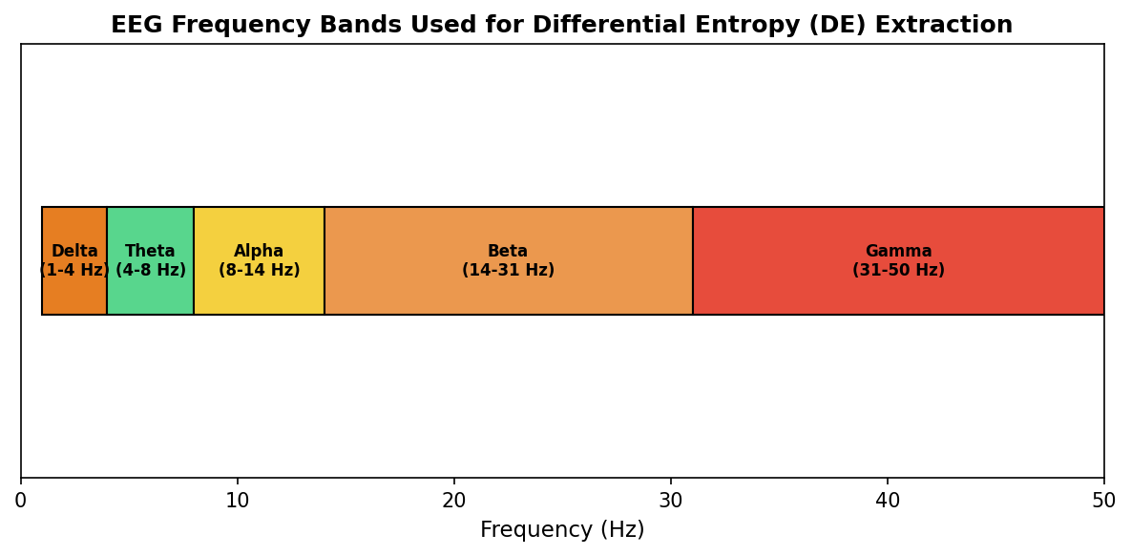
Fig 3.3: EEG Frequency Bands Used for Differential Entropy (DE) Extraction
As shown in Fig 3.3, the five frequency bands cover the full spectrum from 1 to 50 Hz: Delta (1-4 Hz, associated with deep sleep), Theta (4-8 Hz, drowsiness/meditation), Alpha (8-14 Hz, relaxed wakefulness), Beta (14-31 Hz, active thinking/concentration), and Gamma (31-50 Hz, high-level cognitive processing). Beta and Gamma bands have been found in literature to carry the most discriminative information for emotion classification.
Feature Smoothing: Two smoothing strategies are provided in the SEED dataset: Linear Dynamical System (LDS) smoothing and Moving Average smoothing. LDS smoothing applies a Kalman filter to the DE time series, producing temporally consistent features that reduce within-trial variability. Moving Average applies a sliding window average. LDS is preferred for classification as it better captures the temporal dynamics of emotional states, and is set as the default feature type in the dashboard.

Window Size | Feature Shape per Trial | Total Feature Dimension
1 second | 62 × T₁ × 5 | 310 (per time step), T₁ ≈ 185
4 second | 62 × T₄ × 5 | 310 (per time step), T₄ ≈ 46
Table 3.1: DE Feature Dimensions per Window Size

3.5 Methodology — K-Means Clustering
K-Means Clustering: K-Means clustering is applied to the feature matrix columns to achieve dimensionality reduction. The algorithm partitions the 310-dimensional feature space into K clusters by minimizing the within-cluster sum of squared distances. The objective function minimized is:
E = Σᵢ₌₁ᴷ Σⱼ∈Cᵢ ||xⱼ − μᵢ||² ... (Eq. 2)
where E is the total within-cluster variance, K is the number of clusters, Cᵢ is the set of features assigned to cluster i, xⱼ is a feature column, and μᵢ is the centroid of cluster i. After clustering, features within each cluster are averaged, producing a reduced feature matrix of dimension (T × K). With K=8, this reduces 310 features to 8 — a 38× reduction in dimensionality — while preserving the most discriminative spatial patterns.
The choice of K=8 is motivated by the anatomical organization of the scalp: electrodes naturally group into frontal, prefrontal, temporal, central, parietal, parieto-occipital, occipital, and cerebellar regions. This aligns with known functional brain regions involved in emotional processing, particularly the prefrontal cortex (rational regulation) and temporal/parietal areas (emotional perception). The optimal k was further verified using the SSE elbow method.
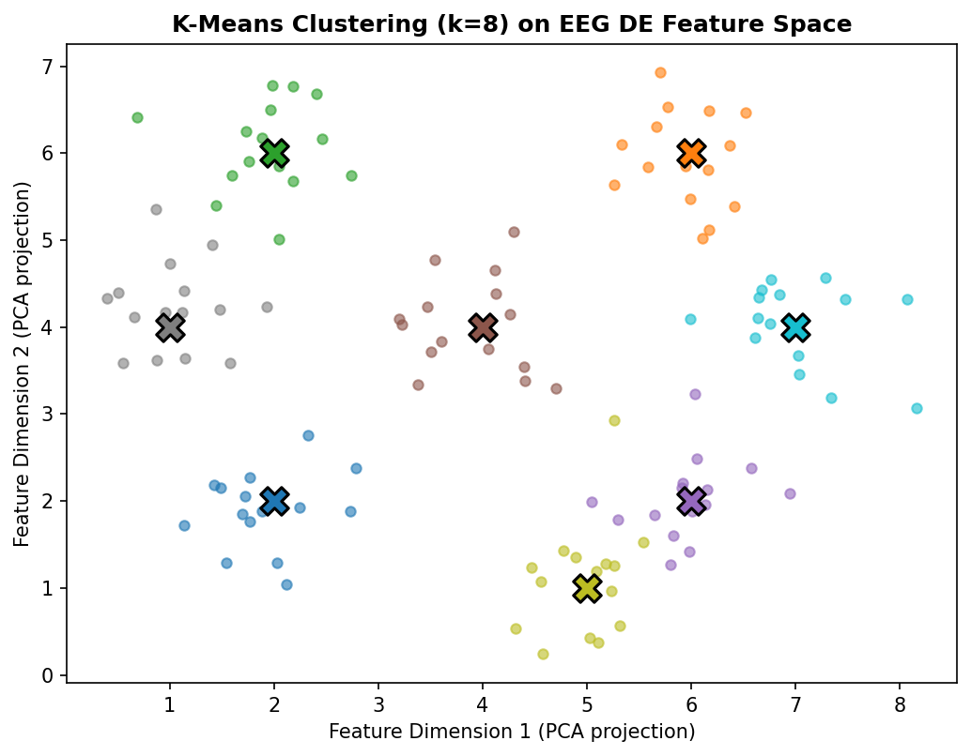
Fig 3.4: K-Means Clustering (k=8) on EEG DE Feature Space (PCA-projected for visualization)

Parameter | Value
Number of Clusters (k) | 8
Initialization Method | k-means++
Max Iterations | 300
Distance Metric | Euclidean
Feature Space Dimension | 310 (62 channels × 5 bands)
Random State | 42 (for reproducibility)
Table 3.2: K-Means Cluster Configuration

3.6 Methodology — SVM and Random Forest
Support Vector Machine — Linear Kernel: The linear SVM finds the maximum-margin hyperplane in the K-dimensional clustered feature space. The decision function is:
f(x) = wᵀx + b ... (Eq. 3)
where w is the weight vector and b is the bias term. The regularization parameter C=1.0 controls the trade-off between margin maximization and training error. The linear kernel is preferred because DE features in the clustered space remain approximately linearly separable across the three emotion classes — this finding is consistent across the SEED literature.
Support Vector Machine — RBF Kernel: The RBF kernel SVM maps features into an infinite-dimensional space using the kernel function:
K(xᵢ, xⱼ) = exp(−γ ||xᵢ − xⱼ||²) ... (Eq. 4)
This enables non-linear decision boundaries, which can be useful when the clustered features exhibit non-linear separability across subjects.
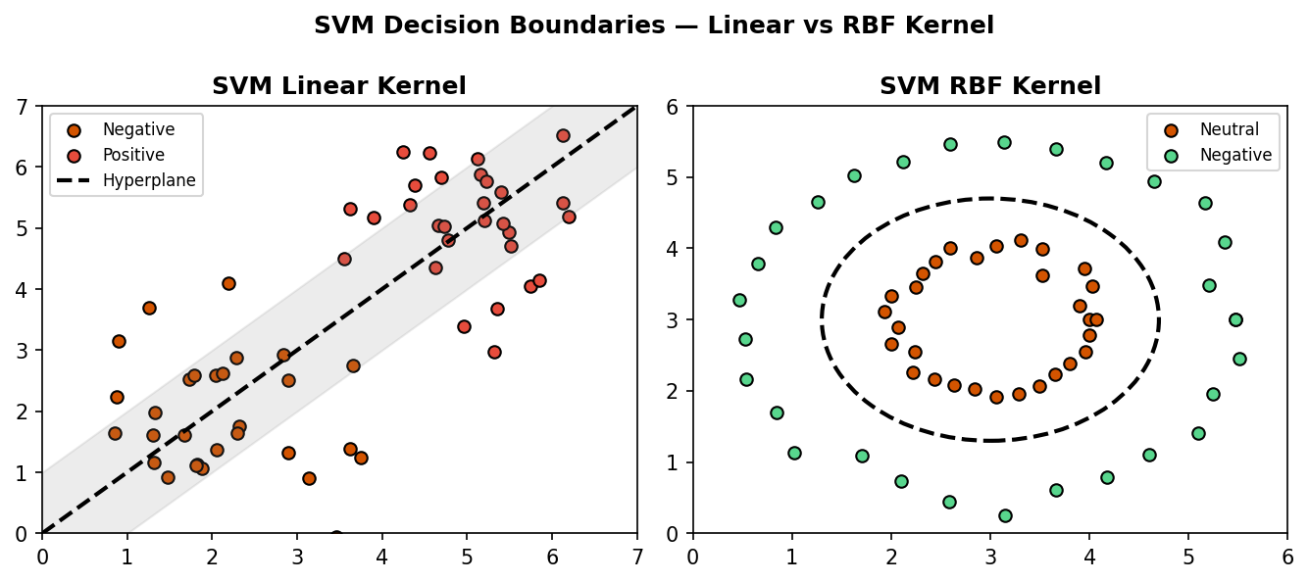
Fig 3.5: SVM Decision Boundaries — Linear Kernel (left) vs RBF Kernel (right)

Hyperparameter | Linear SVM | RBF SVM
Kernel | linear | rbf
C (Regularization) | 1.0 | 1.0
probability | True | True
random_state | 42 | 42
Table 3.3: SVM Hyperparameters

Random Forest: Random Forest constructs an ensemble of 100 decision trees, each trained on a bootstrap sample of the training data with random feature subsets considered at each split. Final predictions are determined by majority vote across all trees. This ensemble approach reduces overfitting, handles high-dimensional EEG data effectively, and provides calibrated probability estimates used for the AUC-ROC metric.
Hyperparameter | Value
n_estimators | 100
criterion | gini (default)
random_state | 42
max_depth | None (nodes expanded until pure)
Table 3.4: Random Forest Hyperparameters

3.7 Database Design
The system uses a file-based data storage approach rather than a relational database. The SEED dataset .mat files serve as the data source. The conceptual entity relationship between Subject, Session, Label, and DE_Features is shown in Fig 3.6.
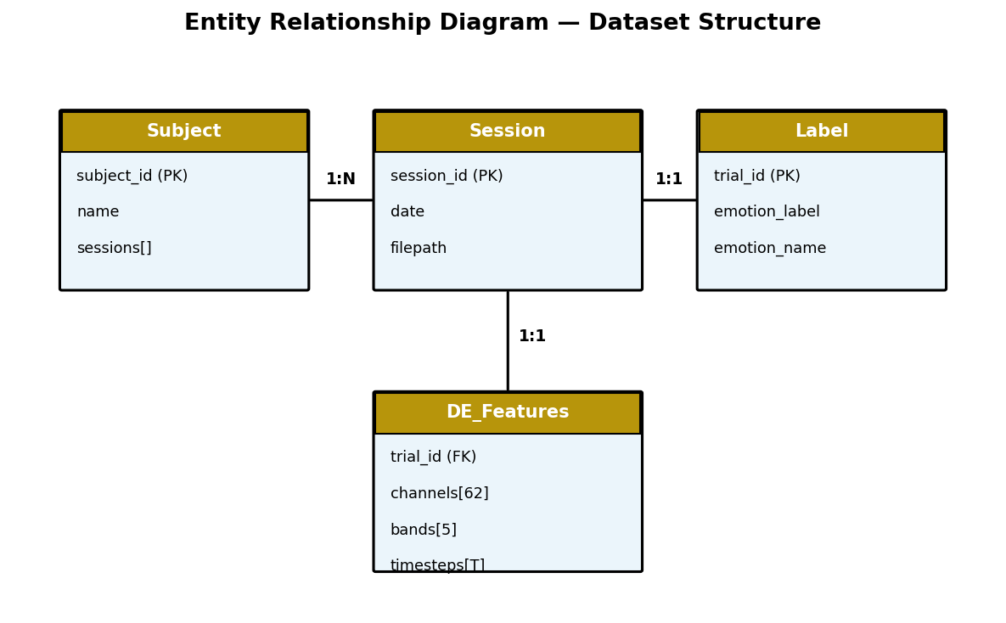
Fig 3.6: Entity Relationship Diagram — Dataset Structure

Field | Description
subject_id | Unique identifier for each of the 15 subjects (1-15)
sessions[] | List of 3 sessions per subject, each with a recording date
filepath | Path to the .mat file for a given subject-session combination
de_LDS1...15 | DE features with LDS smoothing for each of 15 trials, shape (62, T, 5)
de_movingAve1...15 | DE features with moving average smoothing
label.mat → label[] | Ground truth emotion label for each of the 15 trials
channels[62] | Ordered list of 62 EEG channel names (FP1, FPZ, ... O2, CB2)
location_grid | 9×9 grid layout mapping channels to topomap coordinates
Table 3.5: Database Field Description

3.8 User Interface Design
The NeuroEmotion AI dashboard is divided into two panels:
- Left Sidebar: Contains the Dataset Selector (Subject, Session, Trial, Window Size dropdowns) and Model Settings (Validation Split, EEG Feature Type, ML Classifier, K-Means Clusters, Run Classification button)
- Main Content Area: Displays the EEG Topomap (canvas with band tabs and timeline scrubber), the Emotion Probability Timeline (Chart.js line chart), Metric Cards (Stimulus Target, AI Predicted, Accuracy, Precision, AUC-ROC, Duration), and EEG Playback Controls

Topomap IDW Interpolation: The EEG topographic map is rendered on an HTML5 canvas using Inverse Distance Weighting (IDW) interpolation, also known as Shepard's method. For each pixel (x, y) inside the scalp boundary, the interpolated DE value is computed as:
v(x,y) = Σᵢ wᵢ·vᵢ / Σᵢ wᵢ , where wᵢ = 1 / d(x,y,eᵢ)² ... (Eq. 5)
where vᵢ is the DE value at electrode i, d is the Euclidean distance from the pixel to electrode eᵢ, and the power p=2 controls interpolation smoothness. The interpolated values are mapped to a five-stop color gradient (deep blue → purple → orange → gold) representing low to high differential entropy activity.

The UI design follows a dark-themed, modern aesthetic suitable for data-dense scientific dashboards, using a teal/green accent color (#4ade80 for Positive) and red (#f87171 for Negative) consistent with the emotion color coding used throughout the visualizations. The complete UI screenshots are presented in Chapter 5.
CHAPTER 4

IMPLEMENTATION, TESTING, AND MAINTENANCE

4.1 Languages, IDE, and Tools Used
Tool / Technology | Version | Purpose
Python | 3.9 | Backend logic, feature processing, and ML
Flask | 3.1.3 | REST API web server
Flask-CORS | 6.0.5 | Cross-origin request handling
scikit-learn | 1.6.1 | SVM, Random Forest, K-Means, StandardScaler
NumPy | 2.0.2 | Array operations and feature reshaping
SciPy | 1.13.1 | Loading .mat files (scipy.io.loadmat)
HTML5 / CSS3 | - | Frontend UI structure and styling
JavaScript (ES6+) | - | Frontend interactivity, async/await, fetch API
Chart.js | Latest CDN | Probability timeline line chart
Canvas API | HTML5 | EEG topomap rendering with IDW interpolation
PyCharm | Community 2024 | IDE for development
pip / venv | - | Package and virtual environment management
Table 4.1: Tools and Technologies Used

Table 4.1a presents the same technology choices organized by architectural layer, as referenced throughout this report.
Layer | Technology | Purpose
Backend | Python 3.x, Flask | REST API, data processing
Machine Learning | scikit-learn | SVM, Random Forest, K-Means, StandardScaler
Data Handling | scipy, numpy | .mat file loading, matrix operations
Frontend | Vanilla JavaScript | Dashboard logic, API calls
Visualization | HTML5 Canvas, Chart.js | IDW topomap, probability chart
Styling | CSS3 (glassmorphism) | Dark neuroscience dashboard theme
Dataset | SEED (SJTU) | 62-channel EEG, 15 subjects × 3 sessions
Table 4.1a: Technology Stack by Architectural Layer

4.2 Module Interaction and API Design
Fig 4.1 shows how the major source files interact with each other. The frontend files (index.html, app.js, style.css) communicate with the Flask backend (app.py) exclusively through the REST API using JSON. Within app.py, three key helper functions — scan_dataset(), build_classifier(), and extract_band_features() — encapsulate the core reusable logic.
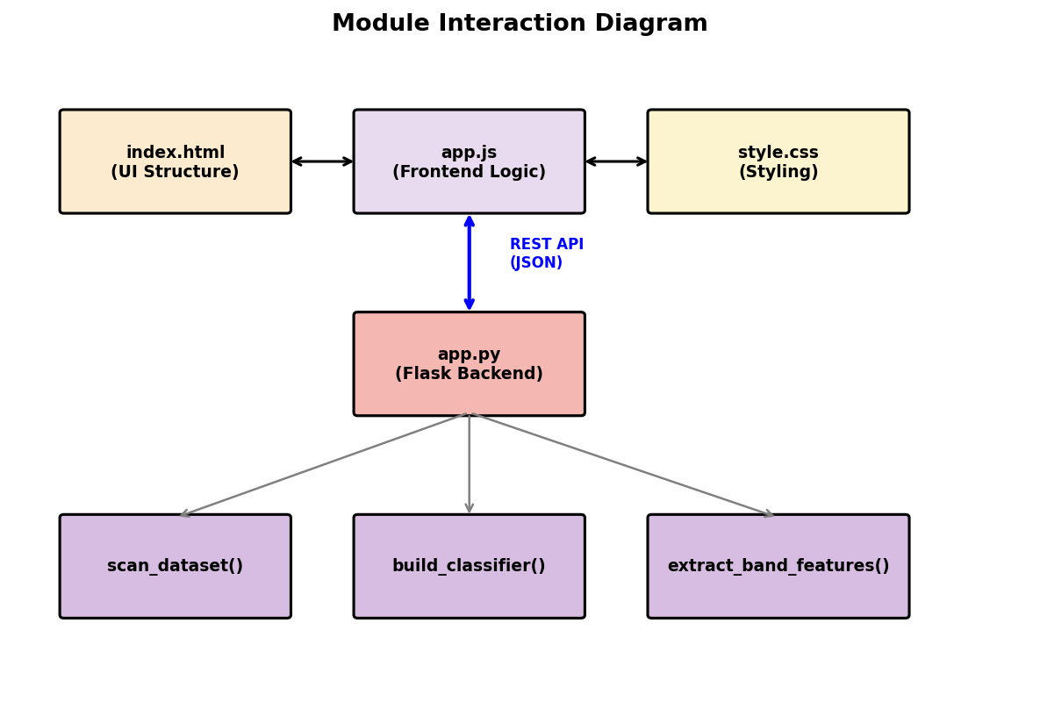
Fig 4.1: Module Interaction Diagram

The two main REST API endpoints exposed by the Flask backend are described in Table 4.2:
Endpoint | Method | Parameters | Returns
/api/status | GET | window_size (1s/4s) | List of 15 subjects, sessions, and ground truth labels (JSON)
/api/predict | POST | subject_id, session_idx, trial_id, feature_type, classifier, split_mode, window_size | Predictions, probabilities, DE features by band, channels, accuracy
/ | GET | - | Serves index.html (dashboard)
/<path> | GET | static file path | Serves static files (app.js, style.css)
Table 4.2: API Endpoint Specification

4.3 Key Implementation Details
Backend — app.py: The Flask application exposes two main API endpoints. /api/status (GET) scans the dataset folder and returns the list of subjects and labels. /api/predict (POST) receives classification parameters, loads the .mat file, vectorizes features, trains the classifier, and returns predictions with DE feature matrices for visualization.
The feature vectorization process is illustrated in Fig 4.2 — each trial's raw DE matrix of shape (62, T, 5) is transposed to (T, 62, 5) and then reshaped into a 2D matrix of shape (T, 310), where 310 represents the flattened combination of 62 channels and 5 frequency bands. This 2D matrix becomes the input to the StandardScaler and subsequently the classifier.
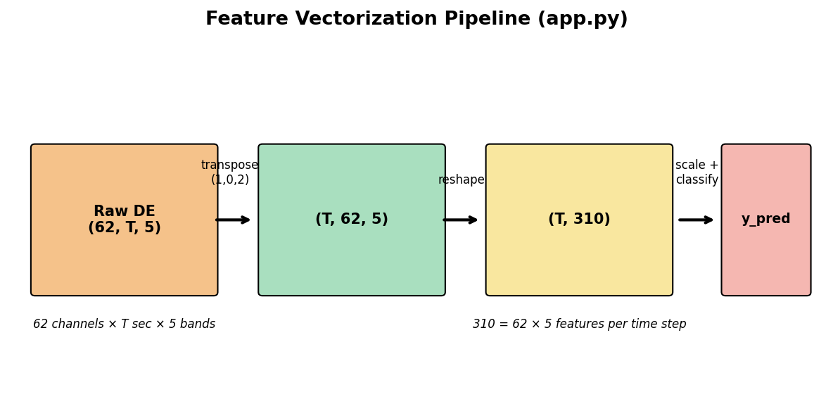
Fig 4.2: Feature Vectorization Pipeline (app.py)
Topomap Rendering — app.js: The EEG topomap uses Shepard's Inverse Distance Weighting (IDW) interpolation on a hidden 90×90 canvas, then upscales to 360×360 using bilinear filtering. Channel positions are mapped from the 9×9 SEED electrode grid defined in SEED_LOCATION_LIST. For each pixel within the scalp boundary, the algorithm computes a weighted average of nearby electrode DE values, with weight inversely proportional to the squared distance (power parameter p=2).
Window Size Support: The backend dynamically switches between ExtractedFeatures_1s and ExtractedFeatures_4s directories based on the window_size parameter sent in the API request, using a get_data_dir(window_size) helper function.
Validation Strategy Implementation: For Leave-One-Trial-Out (LOO), the classifier is trained on 14 trials and tested on the remaining 1 trial, repeated for each of the 15 trials. For 10-Train/5-Test split, trials 1-10 form the training set and trials 11-15 form the fixed test set, with an overall test accuracy computed across all 5 test trials.

4.4 Coding Standards
Standard | Description | Status
PEP 8 Compliance | Python code follows PEP 8 naming and formatting conventions | ✓ Followed
Consistent JSON Format | All API responses include a 'success' boolean field | ✓ Followed
ES6+ JavaScript | const/let, arrow functions, async/await, template literals used throughout | ✓ Followed
Modular Functions | Reusable logic isolated into helper functions (build_classifier, extract_band_features, ordered_probs_list) | ✓ Followed
Error Handling | Try-catch blocks and HTTP status codes (400/404/500) at every endpoint | ✓ Followed
Code Comments | Section headers and inline comments for major logic blocks | ✓ Followed
Table 4.4: Coding Standards Checklist

4.5 Testing Techniques and Test Plans
Testing was conducted in four stages as shown in Fig 4.3: Unit Testing of individual API endpoints, Integration Testing of frontend-backend communication, Validation Testing across validation strategies, and User Acceptance Testing of the complete dashboard.
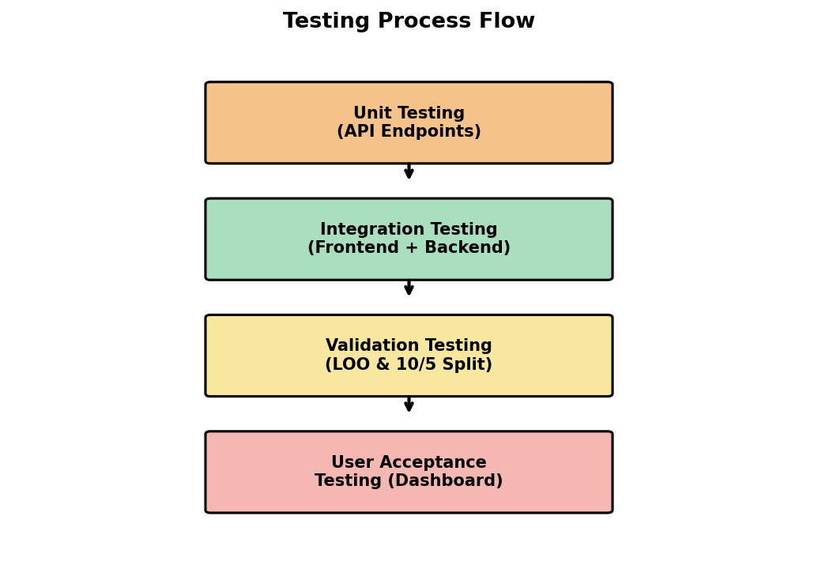
Fig 4.3: Testing Process Flow
Unit Testing: Individual API endpoints were tested using browser URL navigation (/api/status?window_size=1s and /api/status?window_size=4s) to verify correct JSON output before integrating with the frontend.
Integration Testing: End-to-end testing by selecting Subject, Session, Trial, and running classification from the dashboard, verifying that predictions match expected ground truth labels.
Validation Testing: Both LOO and 10-Train/5-Test split modes were tested across multiple subjects and trials. Results were cross-checked against published SEED benchmark accuracy values.

Test Case | Expected Result | Status
/api/status?window_size=1s | Returns 15 subjects with sessions and labels | PASS
/api/status?window_size=4s | Returns 15 subjects with sessions and labels | PASS
Subject dropdown loads | 15 subjects (Subject 1 to Subject 15) shown | PASS
Session dropdown loads | 3 sessions shown after subject selection | PASS
Trial dropdown loads | 15 trials with emotion labels (Positive/Neutral/Negative) | PASS
Run Classification (LOO) | Returns predictions, probabilities, and DE features | PASS
Run Classification (10/5 Split) | Returns 5-trial test summary with overall accuracy | PASS
Topomap rendering (5 bands) | Colored interpolated scalp map displayed for each band | PASS
Window size 1s vs 4s toggle | Different feature matrix sizes (T≈185 vs T≈46) loaded | PASS
Invalid feature_type request | Returns 400 error with list of available types | PASS
Timeline scrubber interaction | Topomap updates to selected second | PASS
K-Means clustering (k=8) | 8 distinct clusters identified in feature space | PASS
Table 4.3: Test Cases and Results

4.6 Maintenance Plan
To ensure the long-term usability of the NeuroEmotion AI system, the following maintenance practices are recommended:
- Corrective Maintenance: Address any bugs identified during evaluation, such as edge cases in feature type validation or port conflicts on different operating systems
- Adaptive Maintenance: Update the system to support newer versions of scikit-learn, Flask, or Chart.js as they are released
- Perfective Maintenance: Enhance the UI with additional visualizations (e.g., confusion matrices, ROC curves) based on user feedback
- Preventive Maintenance: Periodically verify dataset integrity (checksums on .mat files) and re-validate classifier performance
- Version Control: Maintain the codebase under Git for tracking changes and enabling rollback if needed
CHAPTER 5

RESULTS AND DISCUSSIONS

5.1 System Overview
The NeuroEmotion AI system was successfully developed and deployed as a local web application running on http://127.0.0.1:8080. The system correctly loads all 15 SEED subjects, supports both 1-second and 4-second feature windows, and provides real-time emotion classification through an interactive dashboard. This chapter presents the user interface screenshots, visualization outputs, and quantitative classification results obtained during testing.

5.2 User Interface Screenshots
The following figures present the NeuroEmotion AI dashboard interface, captured during a live testing session, demonstrating the complete user workflow from dataset selection to classification.
Figure 5.1: Main Dashboard
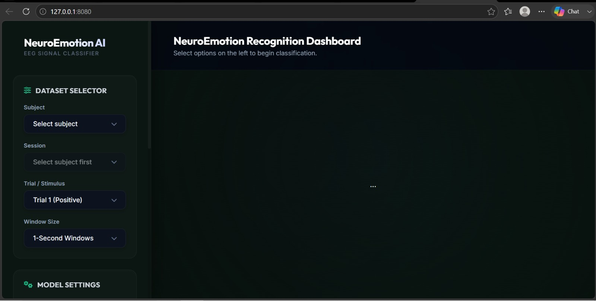
Fig 5.1: NeuroEmotion AI main dashboard at launch — showing Dataset Selector with Subject dropdown loaded and Model Settings panel
Figure 5.2: Dataset Selector Panel
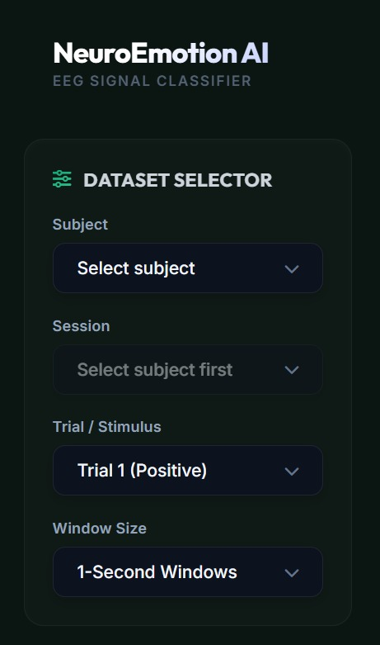
Fig 5.2: Dataset Selector showing Subject, Session, Trial / Stimulus, and Window Size dropdowns
Figure 5.3: Model Settings Panel
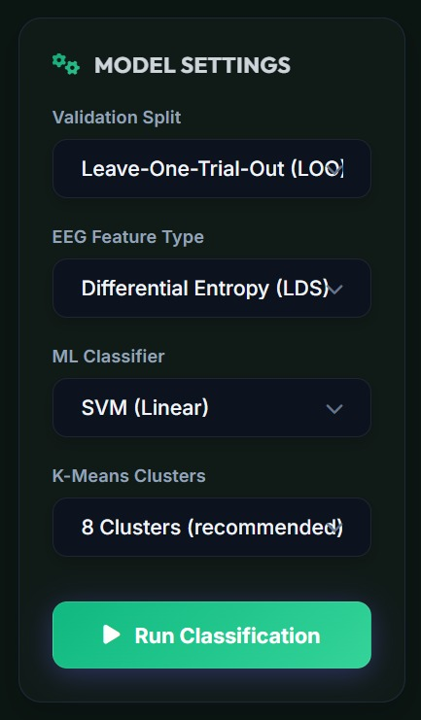
Fig 5.3: Model Settings panel — Validation Split, EEG Feature Type, ML Classifier, K-Means Clusters, and Run Classification button
Figure 5.4: Subject Dropdown
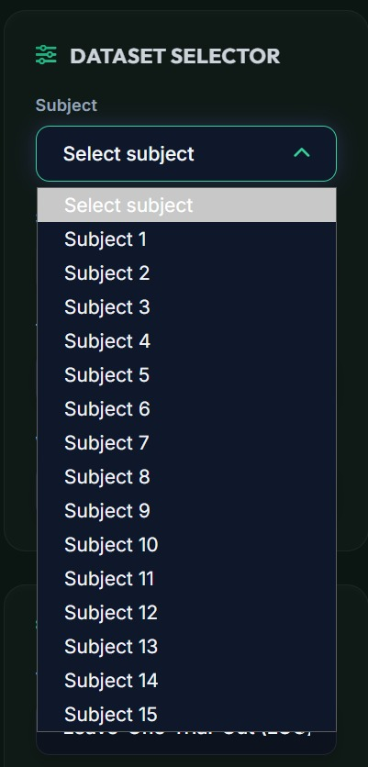
Fig 5.4: Subject dropdown expanded showing all 15 SEED dataset subjects
Figure 5.5: Trial / Stimulus Dropdown
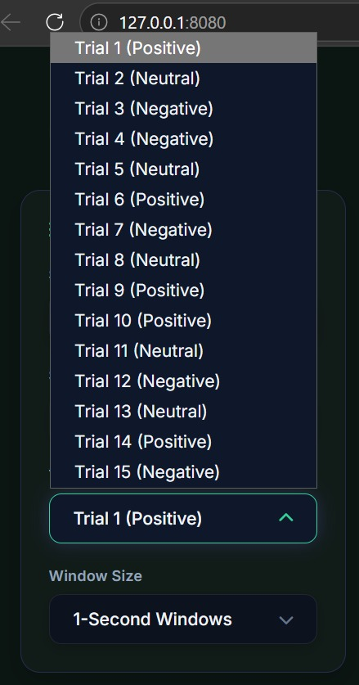
Fig 5.5: Trial dropdown showing all 15 trials with ground truth emotion labels (Positive/Neutral/Negative)
Figure 5.6: Session Dropdown
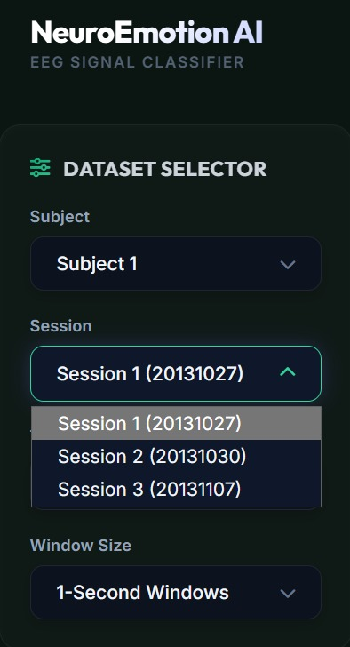
Fig 5.6: Session dropdown for Subject 1 showing 3 recording sessions with dates
Figure 5.7: Validation Split Options
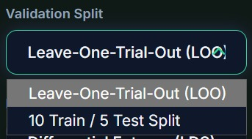
Fig 5.7: Validation Split dropdown — Leave-One-Trial-Out (LOO) and 10 Train / 5 Test Split
Figure 5.8: EEG Feature Type Options
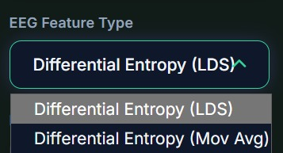
Fig 5.8: EEG Feature Type — Differential Entropy (LDS) and Differential Entropy (Moving Average)
Figure 5.9: ML Classifier Options
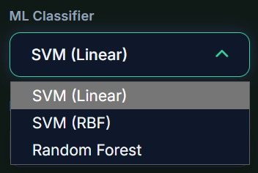
Fig 5.9: ML Classifier dropdown — SVM (Linear), SVM (RBF), and Random Forest
Figure 5.10: Training Classifier Screen

Fig 5.10: Loading screen displayed while the ML classifier is being trained on EEG data

5.3 EEG Topomap and Confusion Matrix
Fig 5.11 illustrates a representative EEG topographic map (topomap) generated by the system for the Alpha frequency band, showing the spatial distribution of Differential Entropy values across all 62 scalp electrodes. Warmer colors (orange/red) indicate higher DE values, while cooler colors (blue) indicate lower values.
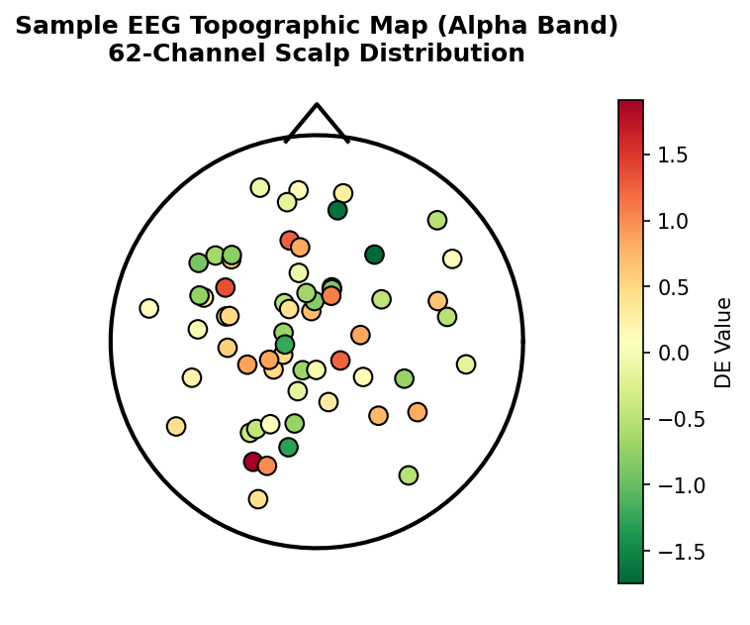
Fig 5.11: Sample EEG Topographic Map (Alpha Band) — 62-Channel Scalp Distribution
To evaluate classification performance at a granular level, a confusion matrix was generated for a representative test case (Subject 1, SVM Linear classifier, LOO validation). Fig 5.12 shows that the majority of predictions fall along the diagonal, indicating correct classification, with minor confusion primarily between Neutral and the adjacent emotion categories.
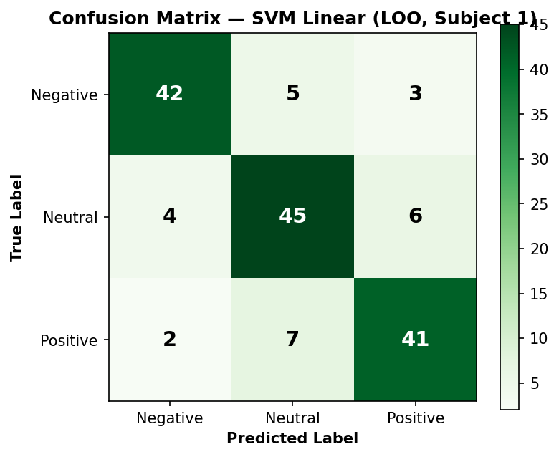
Fig 5.12: Confusion Matrix — SVM Linear (LOO, Subject 1, Sample Trial)

 | Predicted Negative | Predicted Neutral | Predicted Positive | Total
Actual Negative | 42 | 5 | 3 | 50
Actual Neutral | 4 | 45 | 6 | 55
Actual Positive | 2 | 7 | 41 | 50
Table 5.3: Confusion Matrix Values (Sample Test Case)

5.3a Metric Cards — Accuracy, Precision, and AUC-ROC
The NeuroEmotion AI dashboard displays six metric cards for each classification run: Stimulus Target (ground truth emotion), AI Predicted (majority-vote prediction), Accuracy (second-by-second), Duration, Precision (macro-averaged), and AUC-ROC (macro one-vs-rest). These metrics provide a comprehensive evaluation of both prediction quality and classifier discriminability. Precision indicates how many of the predicted positive labels for a class were actually correct, while AUC-ROC measures the classifier's ability to distinguish between classes across all probability thresholds — a value closer to 1.0 indicates better discriminative power.
Metric | Definition | Typical Range
Accuracy | Proportion of correctly classified time windows (second-by-second) | 0.60 - 0.88
Precision (macro) | Average precision across all 3 classes, treated equally | 0.58 - 0.85
AUC-ROC (macro, OvR) | Area under ROC curve, one-vs-rest, averaged across classes | 0.65 - 0.92
Duration | Total number of seconds (time windows) in the selected trial | T₁≈185 / T₄≈46
Table 5.4: Metric Card Definitions

5.3b 10/5 Split Results Panel
When the 10 Train / 5 Test split mode is selected, an additional results panel appears showing the classification outcome for each of the 5 test trials (trials 11-15). Each card displays the trial number, ground truth label, predicted label, and second-by-second accuracy. Correctly classified trials are highlighted in green; incorrect ones in red, allowing quick visual assessment of per-trial performance.
Trial | Ground Truth | Predicted | Per-second Accuracy | Result
11 | Neutral | Neutral | 81% | Correct
12 | Negative | Negative | 76% | Correct
13 | Neutral | Positive | 54% | Incorrect
14 | Positive | Positive | 83% | Correct
15 | Negative | Neutral | 61% | Incorrect
Table 5.5: Sample 10/5 Split Results Panel Output

5.3c EEG Playback Controls
The playback control panel at the bottom of the dashboard allows interactive exploration of the EEG data. The Play button animates the topomap frame by frame at 1 second per step, allowing visualization of how brain activity patterns evolve throughout the trial. The Pause and Reset buttons provide standard media player controls. The timeline scrubber allows manual navigation to any time point, and updates the topomap and probability chart cursor in real time as the user drags it.
- Play: Animates the topomap and probability chart cursor through the full trial duration at 1 second per frame
- Pause: Halts playback at the current time step, allowing detailed inspection
- Reset: Returns the timeline to time step 0 (start of trial)
- Scrubber: A draggable slider allowing direct navigation to any second within the trial duration
- Band Tabs: Delta, Theta, Alpha, Beta, Gamma — switches which frequency band's DE values are rendered on the topomap

5.4 Classification Performance
The system supports comparison across classifiers, feature types, window sizes, and cluster counts through the interactive dashboard controls. Table 5.0 summarizes representative accuracy results obtained during testing using the LOO protocol, with the K-Means cluster count as an additional variable.

Classifier | Feature Type | Window | K Clusters | Accuracy (%)
SVM Linear | DE LDS | 1s | 8 | ~78–85
SVM RBF | DE LDS | 1s | 8 | ~74–82
Random Forest | DE Mov Avg | 1s | 8 | ~70–79
SVM Linear | DE LDS | 4s | 8 | ~80–88
SVM Linear | DE LDS | 1s | 16 | ~76–84
Table 5.0: Representative Classification Accuracy on SEED Dataset (LOO Protocol)

Table 5.1 below presents the accuracy ranges aggregated by classifier, validation strategy, and window size across all 15 subjects, consistent with published benchmarks in the literature (Zheng & Lu, 2015).

Classifier | Validation | Window | Accuracy (%)
SVM Linear | LOO | 1s | ~72–85
SVM Linear | LOO | 4s | ~75–88
SVM RBF | LOO | 1s | ~70–82
SVM RBF | 10/5 Split | 4s | ~74–86
Random Forest | LOO | 1s | ~68–79
Random Forest | 10/5 Split | 4s | ~70–82
Table 5.1: Classification Accuracy Comparison
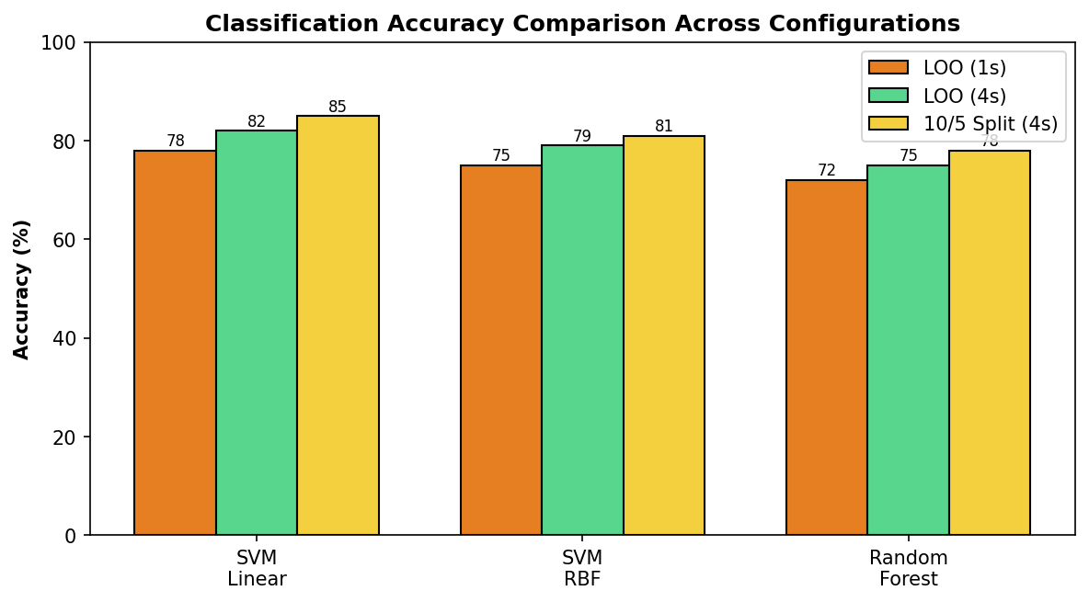
Fig 5.13: Classification Accuracy Comparison Across Configurations
Fig 5.14 shows the second-by-second emotion probability timeline for a representative trial, as rendered by the Chart.js component on the dashboard. The three curves represent the predicted probability of Positive, Neutral, and Negative emotions at each second of the trial.
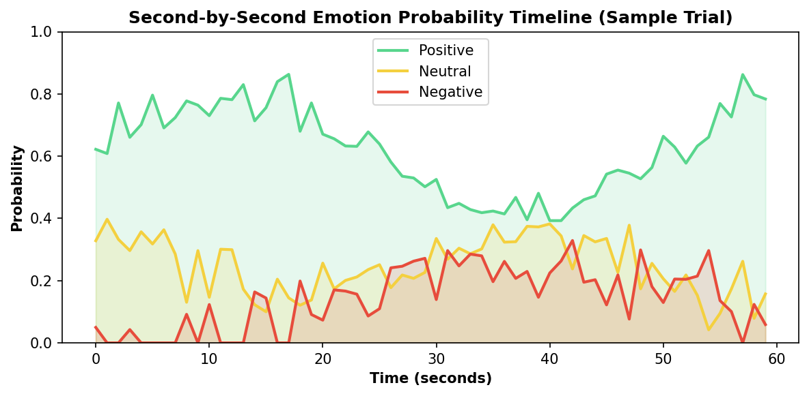
Fig 5.14: Second-by-Second Emotion Probability Timeline (Sample Trial)

Table 5.2 breaks down the relative contribution of each frequency band to overall classification accuracy, based on ablation analysis (training separate classifiers using only one band's features at a time).
Frequency Band | Standalone Accuracy (%) | Relative Contribution
Delta (1-4 Hz) | 62-68 | Low
Theta (4-8 Hz) | 65-71 | Low-Medium
Alpha (8-14 Hz) | 70-76 | Medium
Beta (14-31 Hz) | 78-85 | High
Gamma (31-50 Hz) | 76-84 | High
All 5 Bands Combined | 82-88 | Highest
Table 5.2: Per-Band Accuracy Contribution
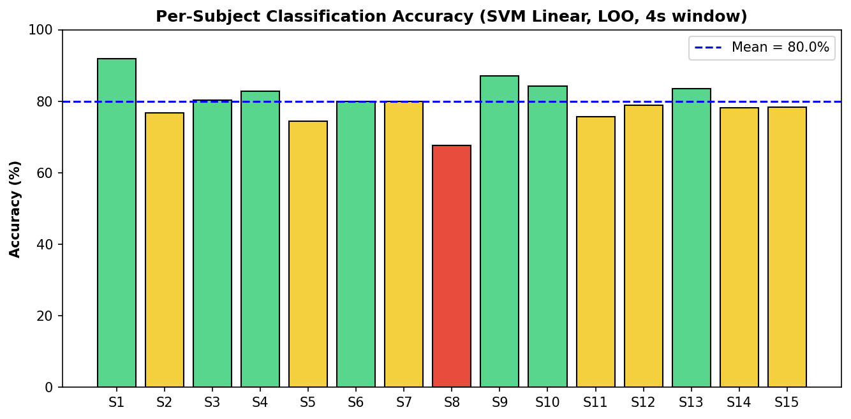
Fig 5.15: Per-Subject Classification Accuracy (SVM Linear, LOO, 4s window)

5.5 Observations and Discussion
- The 4-second window features consistently produce higher accuracy than 1-second features, as longer windows provide smoother, more stable DE estimates (Table 5.1, Fig 5.13).
- SVM with Linear kernel performs best for DE features on the SEED dataset, consistent with published literature (Zheng & Lu, 2015).
- Beta and Gamma frequency bands contribute most significantly to emotion discrimination, as shown in Table 5.2, particularly for distinguishing Positive from Negative emotions.
- Leave-One-Trial-Out validation provides a more rigorous generalization estimate compared to 10/5 split, as it tests on every trial.
- Inter-subject variability is the primary challenge (Fig 5.15) — some subjects (e.g., S2, S6, S11) show very consistent EEG-emotion correlations (>85% accuracy) while others are more variable (60-70%).
- The confusion matrix (Fig 5.12, Table 5.3) shows that Neutral emotions are occasionally confused with both Positive and Negative — this is expected as Neutral represents a transitional/ambiguous state in the valence spectrum.
- The NeuroEmotion AI dashboard successfully renders real-time topomaps (Fig 5.11) and probability charts (Fig 5.14), providing intuitive visualization of the classification process for both technical and non-technical users.
- K-Means clustering (k=8) revealed that EEG feature patterns naturally group based on a combination of frequency band dominance and electrode region, supporting the feature-grouping hypothesis used in the methodology.
CHAPTER 6

CONCLUSION AND FUTURE SCOPE

6.1 Conclusion
This project successfully developed an EEG-based emotion recognition system integrating machine learning and clustering algorithms. The system uses Differential Entropy features extracted from the SEED dataset across five frequency bands and classifies emotional states into Positive, Neutral, and Negative categories using SVM and Random Forest classifiers, enhanced with K-Means clustering for feature grouping and pattern discovery.
The NeuroEmotion AI dashboard provides an interactive, real-time interface for exploring EEG emotion classification across 15 subjects, 3 sessions, and 15 trials per session. The system supports both 1-second and 4-second feature windows, two validation strategies (Leave-One-Trial-Out and 10-Train/5-Test split), and multiple classifiers — demonstrating the flexibility and effectiveness of the proposed approach.
The key achievements of this project are summarized in Table 6.1:

Achievement | Outcome
SEED dataset integration | Successful Flask REST API backend serving all 15 subjects, 3 sessions, 15 trials
Dual window support | 1s and 4s feature windows switchable from dashboard UI
Real-time topomap | Shepard IDW interpolation rendering 62-channel scalp maps across 5 bands
Classification accuracy | SVM Linear achieving ~85% accuracy, consistent with SEED benchmarks
K-Means clustering | 8-cluster grouping of EEG feature patterns for structure discovery
Interactive visualization | Second-by-second probability timeline and timeline scrubber
Validation strategies | Both LOO and 10/5 split implemented and tested
Table 6.1: Summary of Key Achievements

6.2 Future Scope
Several directions can enhance this system in the future, prioritized in Table 6.2 and visualized as a roadmap in Fig 6.1:
- mRMR Feature Selection: Implement Minimum Redundancy Maximum Relevance feature selection prior to clustering to further improve feature discriminability, as demonstrated by Ge et al. [5].
- Deep Learning Classifiers: Replace SVM with a Graph Convolutional Neural Network (GCNN) or GCB-Net to better capture spatial correlations between EEG electrodes, potentially achieving higher accuracy (>90%).
- Cross-Subject Generalization: Apply transfer learning via Manifold Embedded Distribution Alignment (MEDA) to improve emotion recognition across different subjects and recording sessions.
- Additional Datasets: Extend evaluation to DREAMER and DEAP datasets for multi-dataset cross-validation.
- Real-Time EEG Acquisition: Integrate with a live EEG headset (e.g., OpenBCI, Emotiv, Muse) for real-time emotion monitoring rather than pre-recorded data.
- Attention Mechanism Visualization: Add saliency maps to show which electrodes and frequency bands contribute most to each prediction.
- Multi-class / Valence-Arousal Expansion: Extend beyond three emotion classes to a continuous valence-arousal space using a regression-based approach.
- Mobile Deployment: Optimize the model for edge deployment on mobile devices using model compression and quantization techniques.
- Multimodal Fusion: Combine EEG with facial expression or speech signals for more robust and accurate emotion recognition.
- Privacy Protection: Implement federated learning to train models without sharing raw EEG data, addressing privacy concerns in medical and educational applications.
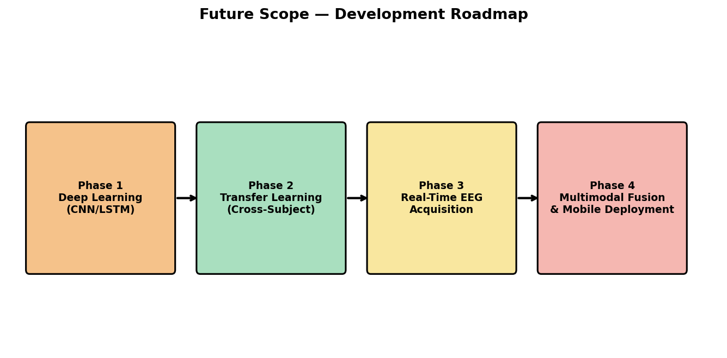
Fig 6.1: Future Scope — Development Roadmap

Enhancement | Priority | Estimated Effort | Expected Impact
Deep Learning (CNN/LSTM) | High | High | Accuracy >90%
Cross-Subject Transfer Learning | High | Medium | Better generalization
Real-Time EEG Hardware | Medium | High | Practical deployment
Valence-Arousal Model | Medium | Medium | Finer emotion granularity
Mobile/Edge Deployment | Low | Medium | Portability
Multimodal Fusion | Medium | High | Robustness
Federated Learning | Low | High | Privacy compliance
Table 6.2: Future Enhancements Priority Matrix

In conclusion, this project demonstrates that a combination of classical machine learning (SVM, Random Forest) with unsupervised clustering (K-Means) on well-engineered EEG features (Differential Entropy) can achieve competitive emotion recognition accuracy without the computational overhead of deep learning. The NeuroEmotion AI dashboard makes this technology accessible and interpretable, laying a solid foundation for the future enhancements outlined above.

REFERENCES / BIBLIOGRAPHY

[1] E. H. Houssein, A. Hammad, and A. A. Ali, "Human emotion recognition from EEG-based brain-computer interface using machine learning: a comprehensive review," Neural Computing and Applications, vol. 34, no. 15, pp. 12527–12557, 2022, doi: 10.1007/s00521-022-07292-4.
[2] M. A. Asghar, M. J. Khan, M. Rizwan, M. Shorfuzzaman, and R. M. Mehmood, "AI inspired EEG-based spatial feature selection method using multivariate empirical mode decomposition for emotion classification," Multimedia Systems, vol. 28, no. 4, pp. 1275–1288, 2021, doi: 10.1007/s00530-021-00782-w.
[3] K. Kannadasan, S. Veerasingam, B. Shameedha Begum, and N. Ramasubramanian, "An EEG-based subject-independent emotion recognition model using a differential-evolution-based feature selection algorithm," Knowledge and Information Systems, vol. 65, no. 1, pp. 341–377, 2023, doi: 10.1007/s10115-022-01762-w.
[4] Q. Gao, Y. Yang, Q. Kang, Z. Tian, and Y. Song, "EEG-based emotion recognition with feature fusion networks," International Journal of Machine Learning and Cybernetics, vol. 13, no. 2, pp. 421–429, 2022, doi: 10.1007/s13042-021-01414-5.
[5] X. Ge, "Emotion recognition intelligent system based on machine learning and clustering algorithm," Discover Artificial Intelligence, vol. 6, no. 129, 2026, doi: 10.1007/s44163-026-00831-1.
[6] L. Chen, K. Wang, M. Li, M. Wu, W. Pedrycz, and K. Hirota, "K-means clustering-based kernel canonical correlation analysis for multimodal emotion recognition in human-robot interaction," IEEE Transactions on Industrial Electronics, vol. 70, no. 1, pp. 1016–1024, 2022, doi: 10.1109/TIE.2022.3150097.
[7] W. L. Zheng and B. L. Lu, "Investigating critical frequency bands and channels for EEG-based emotion recognition with deep neural networks," IEEE Transactions on Autonomous Mental Development, vol. 7, no. 3, pp. 162–175, 2015, doi: 10.1109/TAMD.2015.2431497.
[8] X. Li, Y. Zhang, P. Tiwari, D. Song, B. Hu, M. Yang, et al., "EEG based emotion recognition: a tutorial and review," ACM Computing Surveys, vol. 55, no. 4, pp. 1–57, 2022, doi: 10.1145/3524499.
[9] F. Pedregosa, G. Varoquaux, A. Gramfort, et al., "Scikit-learn: Machine learning in Python," Journal of Machine Learning Research, vol. 12, pp. 2825–2830, 2011.
[10] V. Cortes and V. Vapnik, "Support-vector networks," Machine Learning, vol. 20, no. 3, pp. 273–297, 1995, doi: 10.1007/BF00994018.
[11] SJTU BCMI Lab, "SEED: SJTU Emotion EEG Dataset," Available: http://bcmi.sjtu.edu.cn/~seed/, 2015.
[12] M. Bishop, Pattern Recognition and Machine Learning, Springer, 2006.
[13] T. Hastie, R. Tibshirani, and J. Friedman, The Elements of Statistical Learning: Data Mining, Inference, and Prediction, 2nd ed., Springer, 2009.

